**DS20613 - Assignment 5 – Light Dependent Resistor (LDR)**

**Submitted on 01 December 2020**

**Name:** Theivaprakasham H

**Roll Number:** CB.EN.P2CEN20026

**Light Dependent Resistor**

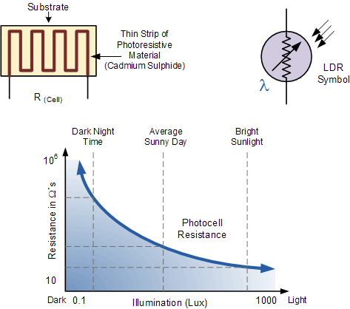

**List of Components**

|  |  |  |
| --- | --- | --- |
| **Name** | **Quantity** | **Component** |
| U2 | 1 | Arduino Uno R3 |
| R1 R5 | 2 | Photoresistor |
| R2 | 1 | 0.5 kΩ Resistor |
| R3 R4 R6 | 3 | 1 kΩ Resistor |
| D1 D2 | 2 | Red LED |

**Wire Diagram of Pull up and Pull down Configuration of LDR**

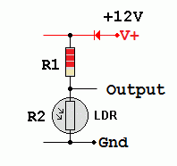 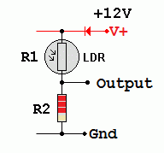

**Pull Up Configuration Pull Down Configuration**

**Vout = Vin x R2 / ( R1 + R2 ) Vout = Vin x R2 / ( R1 + R2 )**

As the light gets brighter, R2   
decreases and the output   
voltage drops.

As the light gets brighter, R1  
decreases and the output   
voltage rises.

**R2 = Vout x R / (Vin-Vout) R1 =R x (Vin - Vout) / Vout**

**Here R2 is the LDR resistance Here R1 is the LDR resistance**

**Applications of LDR in Pull-up and Pull-down Configuration**

**Pull-up –** Smart LED system where the LED switches OFF at high brightness and Switches on at Low Brightness

**Pull-down –** Smart controlling system where the LED switches ON at high brightness and Switches OFF at Low Brightness.

**Breadboard view**

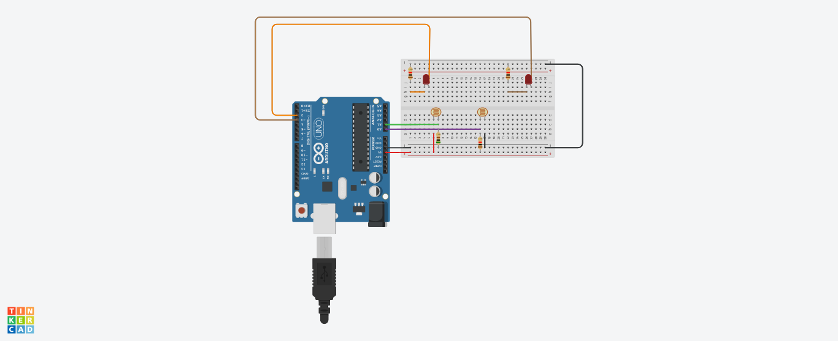

**Live implementation view**

**Case 1: When both LDR has not Light incident on it.**

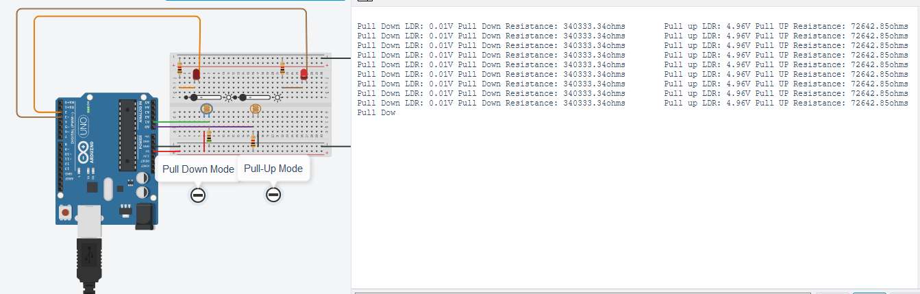



**Pull up Mode:**

When No light is incident on LDR, then the output voltage will be nearly high as the input voltage as the internal impedance of the microcontroller is very high. And so the LED connected to the Digital PIN3 turns HIGH.

Resistance of the LDR will also be very high as no light is incident on it.

**Pull down Mode:**

When No light is incident on LDR, then the output voltage will be nearly zero as the impedance of the LDR is very high and very minimal current flows through it. And so, the LED connected to the Digital PIN2 turns LOW.

Resistance of the LDR will also be very high as no light is incident on it.

**Case 2: When Pull-up LDR alone has Light incident on it.**

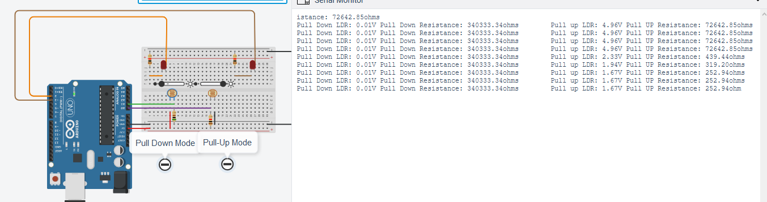



**Pull up Mode:**

When light is incident on Pull-up mode LDR, then the output voltage will reach near Zero value as the LDR resistance decreases drastically. And so, the LED connected to the Digital PIN3 turns LOW.

Resistance of the LDR will decrease as more light is incident on it.

**Pull down Mode:**

When No light is incident on LDR, then the output voltage will be nearly zero as the impedance of the LDR is very high and very minimal current flows through it. And so, the LED connected to the Digital PIN2 turns LOW.

Resistance of the LDR will also be very high as no light is incident on it.

**Case 3: When Pull-down LDR alone has Light incident on it.**

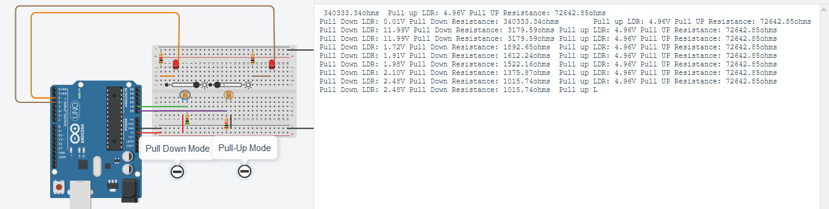



**Pull up Mode:**

When No light is incident on LDR, then the output voltage will be nearly high as the input voltage as the internal impedance of the microcontroller is very high. And so the LED connected to the Digital PIN3 turns HIGH.

Resistance of the LDR will also be very high as no light is incident on it.

**Pull down Mode:**

When light is incident on Pull-down LDR, the output voltage will increase as the resistance of the LDR will be very minimal. And so, the LED connected to the Digital PIN2 turns HIGH.

Resistance of the LDR will decrease as more light is incident on it.

**Code:**

/*

@author: Theivaprakasham H

@title: LDR

*/

**// Initialize Pins**

int pulldownled=2;

int pullupled=3;

float Pull_up_LDR, Pull_down_LDR;

**// Setting up pins**

void setup()

{

pinMode(pullupled, OUTPUT);

pinMode(pulldownled, OUTPUT);

Serial.begin(9600);

}

// Custom function to calculate resistance of LDR in Pullup mode

float resistance_up(float Vout, float rs, float Vin)

{

float r1;

r1 = Vout * rs / (Vin - Vout);

return r1;

}

// Custom function to calculate resistance of LDR in Pulldown mode

float resistance_down(float Vout, float rs, float Vin)

{

float r2;

r2 = (rs*Vin - rs*Vout)/Vout;

return r2;

}

// Custom function to map AnalogRead values into Voltages

float map1(float x, float in_min, float in_max, float out_min, float out_max)

{

return (x - in_min) * (out_max - out_min) / (in_max - in_min) + out_min;

}

void loop()

{

// Reading analog values of Pullup LDR

Pull_up_LDR = map1(analogRead(A0),0,1024, 0.00,5.00);

// Reading analog values of Pulldown LDR

Pull_down_LDR = map1(analogRead(A1),0,1024, 0.00,5.00);

// Printing the Output Voltages and LDR Resistances in Serial monitor

Serial.print((String)"Pull Down LDR: " + Pull_down_LDR + (String)"V " + (String)"Pull Down Resistance: " + resistance_down(Pull_down_LDR, 1000,5 ));

Serial.print("\t");

Serial.println((String)"Pull up LDR: " + Pull_up_LDR + (String)"V " + (String)"Pull UP Resistance: " + resistance_up(Pull_up_LDR, 500,5 ));

// Lighting up an LED using conditions

if(analogRead(A0)>500)

digitalWrite(pullupled,1);

else

digitalWrite(pullupled,0);

if(analogRead(A1)>500)

digitalWrite(pulldownled,1);

else

digitalWrite(pulldownled,0);

}